Photo-Realistic Simulation as a Methodology for Evaluation of 3D Reconstruction of Terrain Maps

Abstract

The quantitative evaluation of digital elevation maps (DEMs) is very important to the scientific advancement of 3D image analysis. This paper presents a new quantitative method of DEM evaluation through the use of synthetic images. In particular, our approach seeks to overcome the well-known problem of lack of available ground-truth data in sufficient quantity across natural terrain (e.g. it is typical that only a few ground control points are available). The proposed method of photo-realistic simulation is based on the assumption that a pre-acquired DEM and ortho-image can serve as the pseudo ground truth for large numbers of points over extended areas of terrain in a cost-effective manner. The proposed methodology utilizes an available high quality terrain map to generate a pair of photo-realistic synthetic images of the terrain. In our domain we begin by using a high resolution DEM and ortho-map to generate two synthetic images from new viewpoints using standard ray tracing algorithms. These images are associated with the known DEM that produced them, which can be reasonably considered “pseudo” ground truth. This technique can serve as a quantitative tool for evaluating the performance of stereo algorithms in 3D reconstruction.

In this paper, by comparing the DEM obtained from a pair of photo-realistic synthetic images with the pseudo ground truth, we can analyze the quantitative error in a DEM and evaluate the effectiveness of this methodology as a tool for other researchers. To verify the effectiveness of the proposed evaluation method, we carry out quantitative and qualitative experiments. As a quantitative experiment, we examine the accuracy of the photo-realistic synthetic image. In a qualitative experiment we examine 3D reconstruction with respect to the size of the correlation window in the UMass terrain reconstruction system, Terrest. Based on experimental results generally agreeing with prediction, we conclude that the tool provided a qualitative assessment of the proposed methodology. This experiment also demonstrates that photo-realistic simulation can serve to tune algorithm parameters in a customized manner to a given image domain, e.g. forest, mountain, desert, etc.

Key words: photo-realistic simulation, DEM, 3D reconstruction, stereo algorithm, ortho-image, synthetic image

I. Introduction

There has been a significant body of research in 3D reconstruction using stereoscopic processing, and a variety of algorithms have been developed for diverse range of applications that include satellite and aerial remote sensing, mobile robotics, industrial inspection, object modeling, etc.[1]-[6] In this study we will concentrate primarily on algorithms that have been developed for aerial imagery with a goal of precise 3D reconstruction for GIS applications. Among the techniques that are most closely related to our own terrain reconstruction system, Terrest [10], are use of multi-resolution schemes [5], NCC (Normalized Cross-Correlation), NSSR (Narrow Search Sub-pixel Registration) [6], etc. In spite of significant advances, there still remain serious unsolved problems and sources of errors in the stereo matching process, such as occlusion, repetitive texture and lack of texture in local windows that must be matched across images in some manner. Therefore, the capability for evaluating the quantitative accuracy of new techniques in the 3D reconstruction process remains very important

Evaluation of the accuracy of a generated DEM is a very difficult task, since it requires a dense array of ground truth. The typical use of a few ground control points among millions and spread out over an entire scene is simply not sufficient to compute meaningful statistics or even reach qualitative conclusions about the applicability of a stereo algorithm for a given domain. Within the domain of aerial imaging the current available technology for obtaining accurate ground truth for large numbers of surface points is airborne scanning laser mapping systems. Unfortunately, collection of such ground truth as a dense array of high resolution elevations, spread out over alarge area (e.g. several kilometers), is a very expensive proposition, and is out of reach for most researchers.

Even in large government-funded programs, such as 3D building and site reconstruction in the DARPA RADIUS and APGD programs from 1993 to 1998, acquisition of ground truth was always a problem. In the case of buildings, the generation of a ground-truth CAD model was achieved using the tools of the Radius Common Development Environment (RCDE), where 3D lines were manually (interactively) placed into 3 or 4 image views to lay over the image lines consistently through the image pose information. With respect to terrain only qualitative evaluation was possible.

The measure of self-consistency [7] introduced by Leclerc is one indirect assessment of DEM accuracy. The idea is based on the fact that two DEMs evaluated by swapping the role of the reference and the target in the stereo matching process should be the same if the matches are correct. Therefore, the difference of the DEMs provides a measure of consistency and reliability. This measure has been demonstrated to be effective for error detection and DEM assessment [8], but it does not directly provide a quantitative error measure for DEMs.

This paper develops a response to the issue of lack of ground truth over large areas of natural terrain. In the paper, we propose a new method for evaluation of DEM accuracy based on ray tracing methods of photo-realistic graphics. Photo-realistic graphics involves state-of-the-art rendering techniques for artificial scenes. Visually realistic rendering requires the simulation of light behavior. Such simulations are computationally complex and very expensive [11]. Ray tracing [12], radiocity [13] and particle tracing [14] are widely used lighting simulation algorithms, and utilize different approaches in approximating light paths. Ray tracing is one of the early methods, the basic principle being that the light intensity of the object hit by the ray from any pixel of the image is assigned to the corresponding pixel. The illumination model of objects that describes the light interaction with surface characteristic with respect to the lighting direction determines the light intensity of the object. **** NEED TO REPHRASE ****

We assume that a pre-acquired high quality DEM with an associated ortho-image can serve as ground truth, and we refer to this as the “pseudo” ground truth DEM. Then synthetic images can be generated from new viewpoints by employing the basic principle of ray tracing on the “pseudo” ground truth DEM. Unlike ray tracing algorithms in photo-realistic graphics, however, the light intensity of each pixel is directly determined by the associated ortho-image, instead of an illumination model. This simple approach significantly decreases the required computation time.

By comparing the pseudo ground truth DEM with the DEM reconstructed from synthetic images, many forms of quantitative analysis are possible, including error analysis of the DEM. Thus, in this paper we propose and evaluate the methodology of photo-realistic simulation as a means of providing the quantitative tools to acquire an unlimited number of psuedo ground truth points across natural terrain at the effective level of resolution associated with original images that are being used in the application domain.

The effectiveness of the proposed evaluation method is demonstrated through quantitative and qualitative experiments. Quantitatively, we examine the accuracy of the photo-realistic synthetic image through measures of similarity to the original images that generated the pseudo DEM. To qualitatively examine the effectiveness of the proposed evaluation method, we apply and evaluate the use of this tool in our own research in a manner that we believe others can also benefit. We perform 3D reconstruction with Terrest [10] applied to synthetic images from photo-realistic simulation, and use the proposed error analysis to determine the best parameters for the size of the correlation window, and compare these results with our intuition and experience. We argue that this analysis can provide significant insight in applying stereo algorithms more effectively to images of new terrain domains.

II. Photo-realistic simulation

In this section we describe a processing sequence for generating synthetic images from a high quality DEM and ortho-image that will serve as a pseudo ground truth DEM for the new synthetic images. A three-dimensional (3D) model is constructed by repeatedly connecting each three adjacent elevation data element subset of a dense grid to form a triangular plane. To determine the projected position of each pixel on the model, we determine the closest intersection between the triangular plane element and the ray from the optical center of the camera model, as shown in Fig. 1. The pixel value of the synthetic image is determined by the bi-linear interpolation of 4 closest pixels of the ortho-image corresponding to the horizontal coordinate of the intersection.
.
Fig. 1 Synthetic image generation

An equation of the line from the optical center O = (x_{o}, y_{o}, z_{o}) to the pixel position P = (x_{p}, y_{p}, z_{p}) is given by

(1)

where the parameter t is constrained to t > 1, since the projected object should be in front of the imaging plane.

An intersection test is performed to obtain the triangular plane that is intersected by the line equation (1). On a 2D array every grid point participates in two triangular planar facets that are associated with a 2 x 2 set of points.

For instance, elements of the grid starting from point (i, j) construct the triangular plane using elevation data associated with (i, j), (i, j+1), (i+1, j+1) and the a second triangular plane is constructed from elevation data of the grid points (i+1, j+1), (i+1, j), (i, j). A DEM with M x N resolution has a total of 2(M-1)(N-1) associated triangular plane elements. However, the intersection test to determine each pixel should not be performed on the entire set of triangular plane elements, because the intersecting triangular plane element exists only in the projection of the line onto the horizontal plane of a DEM

Let the triangular plane element on the projection of the line connect three elevation positions T₁₌(x_{t1}, y_{t1}, z_{t1}), T₂₌(x_{t2}, y_{t2}, z_{t2}), T₃₌(x_{t3}, y_{t3}, z_{t3}). An equation of the plane is given by

(2)

From the equation (1) and (2), we can get a closed-form solution for t and recover the intersected point to the plane (2) by substituting t in equation (1). Here we have two cases of how the intersected point is located. If the recovered point lies within the triangular plane element, an actual intersection occurs and the recovered point will be an intersection of the triangular plane element. Otherwise, the recovered point is outside the triangular plane element and no intersection occurs. Thus, we carry out an intersection test for the existence of the intersection point within the corresponding triangular plane element

The intersection test is applied in 3D space, but it can be simplified to a 2D problem. The test is carried out in one of xy, yz, zx planes by letting z, x, y be zero, respectively. The normal vector of the plane in equation (2) is <C₁₁, C₁₂, C₁₃>, where C₁₁, C₁₂, C₁₃ are the cofactors of the determinant in equation (2). The most accurate intersection test can be done in the plane, where the axis with the largest normal vector element is zero. For instance, if the magnitude of C₁₁ is the largest, the intersection test is performed in the yz plane with x=0.

There are many algorithms for testing the existence of the point inside the triangle[15]. In this paper, we derive a new simple technique utilizing inner products of the vectors for this test. There are vectors connecting three points of the triangular plane element, v₁₂, v₂₃, v₃₁ and vectors from the midpoint to the intersection point p₁, p₂, p₃ , shown in Fig. 2. Given that n₁, n₂, n₃ are the orthogonal vectors of v₁₂, v₂₃, v₃₁, respectively, the angles between n₁, n₂, n₃ and p₁, p₂, p₃ should be in the range of [0°, 90°]. Therefore, the condition of the intersection test is given by
n_{i} • p_{i} ≥ 0 for i=1 to 3 (3)

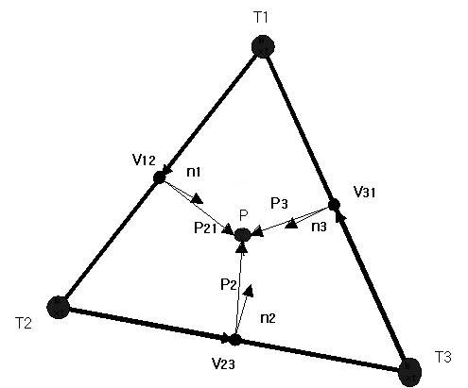
Fig. 2 Intersection test

There might be more than one intersection point satisfying the intersection test. However, the intersection point desired for image synthesis should be the closest to the optical center, which is the intersection point with the largest parameter t in equation (1).

Once we find the intersection point for the synthesis of the image, the pixel value of the synthetic image should be recovered by interpolation, since the coordinate of the ortho-image corresponding to the intersection point can be computed as a real value. Let (i_{x}, i_{y}) be a coordinate of the ortho-image computed from the intersection point (x, y) corresponding to the synthetic image coordinate (l, k). Suppose i and j are truncated integers of i_{x} and j_{y} such that i≤ i_{x} < i+1 and j≤ j_{y} <j+1. The pixel value of synthetic image is interpolated as a weighted sum of values of ortho-images given by
. (4)
In this paper, a well-known bi-linear interpolation is employed for its simplicity and effectiveness. The weights are given by
, (5)
where .

III. Issues in Evaluation of a Photo-Realistic Methodology

Part of our problem in evaluating the accuracy and effectiveness of the proposed methodology of photo-realistic simulation is that it inevitably involves the confounding factor of the quality of the stereo reconstruction algorithm. We depend upon a highly robust and accurate reconstruction capability for generating an initial DEM. Otherwise there would be little likelihood that we could regenerate new synthetic images with image attributes highly similar to the pair of images serving as input to the stereo algorithms, and capturing the surface variation of the original terrain. Thus, we assume such a quality stereoscopic reconstruction algorithm exists, and we believe the UMass Terrest systems satisfies these requirements, and the following experiments support this assertion.

Hence, we propose two quantitative experiments and one qualitative experiment. The first quantitative experiment is to evaluate the degree to which the pseudo ground truth generated from the original images can regenerate the same image data from the given viewpoint. The degree of degradation of the stereo reconstruction process, and therefore the fidelity of regenerating similar synthetic data, can be evaluated for each of the two original images. Under ideal conditions with no noise, the original images should be accurately regenerated, and we will assess the amount of difference.

In the second experiment we attempt to avoid the somewhat circular reasoning associated with evaluating similarity to an image that itself was used to generate the synthetic data. To some unknown degree, even if we perfectly generate the original image of the scene, we cannot be sure that the terrain elevations and associated appearance characteristics of the physical terrain are being effectively captured for the further photo-realistic simulation experiments. In particular, there is the question of whether any new views synthesized with our pseudo ground truth are reasonably representative of the true underlying terrain. Thus, we will employ a third original image with a different viewpoint of the same scene, and use the pseudo ground truth to generate a new view for image comparison of similarity and difference. The difficulty will be that occlusion in the original reconstruction of pseudo ground truth DEMs will cause difficulty here, with some surface areas not having been seen and being generated in the third view by stretching viewed pixels to incorrectly fill in image areas. This problem of occlusion points out a limitation of the methodology because distortion in new synthetic images would reduce their value as a reliable representation of the original terrain. Furthermore, it will immediately affect the evaluation in the experiments that we are about to present.

We consider several possible responses to these problems.

First, for evaluation, we could choose terrain that does not have significant relief. However, this removes some of the most important contexts for this work, which are domains of highly irregular terrain. Second, the fusion of many views of the original scene to generate the pseudo ground truth would allow most surfaces to have at least a pair of unoccluded views, and thereby produce synthetic images with little or no occlusion [8]; this clearly is the ideal solution. Finally, an alternative for evaluation is to perform evaluation with respect to the third image against outliers in matching, but rather only seek to understand the image statistics associated with the noise of modest degradation.

In the last experiment we will use a combined qualitative and quantitative experiment to demonstrate the utility of the methodology for other researchers. In this case we will use photo realistic simulation to determine the optimal value for a parameter that is key in most stereo reconstruction algorithms that are based on dense matching, that is the size of the correlation window in matching between images. This experiment will be qualitative in two senses. There is a strong expectation for the general form of the results based on intuition, theoretic principles, and wide experience in the community. It is also qualitative in that we can assess whether it generally helps us to set an important parameter to customize our terrain reconstruction for a given domain using quantitative simulation results. However, the optimum value of this parameter cannot be known in general because it is likely to vary with characteristics of the image domain, and therefore we argue that others will benefit in tuning their stereo algorithm to their terrain context.

IV. Quantitative Evaluation of Accuracy in Synthetic Image Generation: PART I

Our first method of evaluation is to determine the effectiveness of generating new images from our recovered DEM and ortho-image, where the synthetically generated images should accurately realize the actual scene from the original viewpoint. We will compare the synthetic and the original scene images, and use their similarity as a quantitative measure of analysis. In this experiment a DEM and ortho-image are generated from two original images. The synthetic image is then generated from the DEM and ortho-image with the same camera model of the original image.
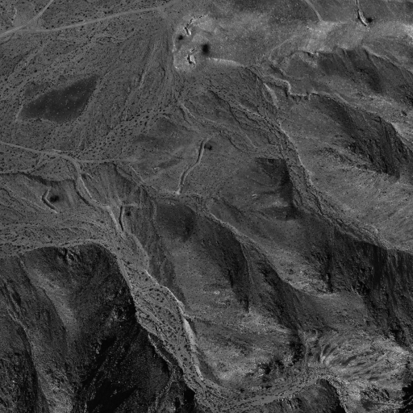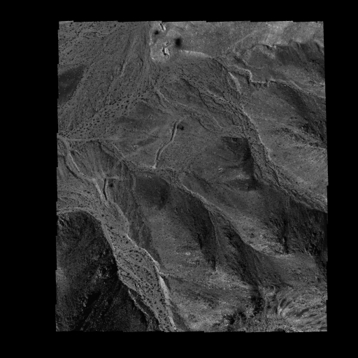
Original image Synthetic Image
Fig. 3 The original image and synthetic image ( 2048 × 2048 )

Fig. 3 shows one of the original reference images and the rendered synthetic image from the DEM and ortho-image generated by Terrest. Note that while the two images are similarly presented and are visually similar, there is a border area of the synthetic image where there are no valid pixels. This is caused by the need for the correlation match window to fit entirely within both images in order to generate an elevation estimate at the central pixel. Given that these windows in the Terrrest system typically vary from 7 x7 to 19 x 19 there is a border of half that size around the overlapping area in the two images (which also might not completely overlap). For closer inspection, magnified sub-images for a central portion are shown in Fig. 4. Examination of this series shows that they preserve shape of regions almost perfectly through all levels of resolution. However, the synthetic image has lower contrast, since interpolation processes are carried out at several points to generate it. **NOT CLEAR WHETHER THIS IS A WINDOW SIZE PROBLEM OR RAY TRACKING PROBLEM -- SHOULD WE REPLACE WITH FOLLOWING?? ** However, there is a marked decrease in contrast that is due to the same problem of the size of the correlation window which acts as a blurring factor across boundaries that the window overlaps. ** HOWARD - ACTUALLY I AM CONFUSED - BECAUSE THE ELEVATIONS WOULD BE BLURRED, BUT I DON’T UNDERSTAND WHY THE ORTHO IMAGE WOULD HAVE ONE OF THE ORIGINAL DRAPED IMAGES HAVE PIXELS WITH LOWER CONTRAST. IS IT DUE TO RENDERING FROM NEW VIEWS? BUT THEN THERE WOULD BE STRETCHING OF ORIGINAL PIXELS.

Now we quantitatively analyze the similarity of the synthetic image to the original image in terms of the matching techniques of Section II. By determining the disparity between the synthetic image and original image, we can evaluate the accuracy of the synthetic image. Terrest [10] employs a sophisticated hierarchical matching process, involving a weighted correlation mask whose size is varied through levels of resolution, sub-pixel interpolation, and median filtering.
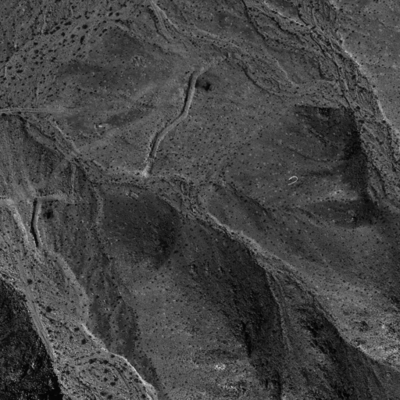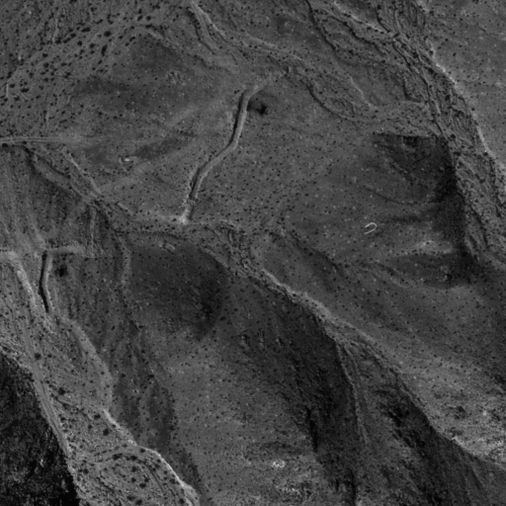
Original image Synthetic Image
- 1024 x 1024
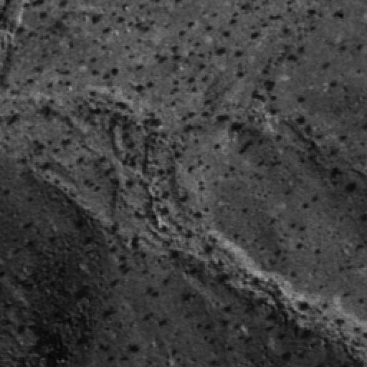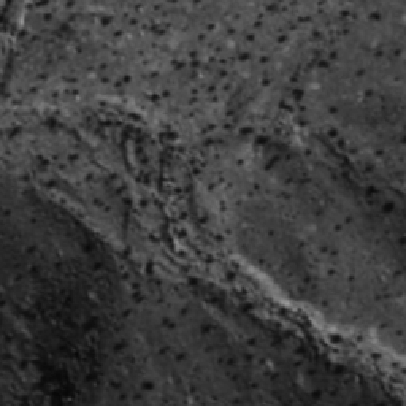
Original image Synthetic Image
- 256 x 256
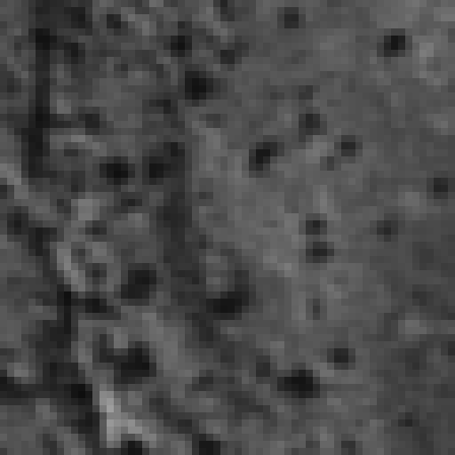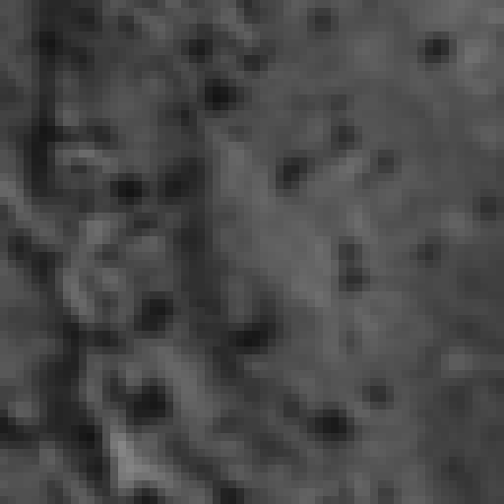
Original image Synthetic Image
- 64 x64

Original image Synthetic Image
- 16 x 16
Fig. 4. The original image and synthetic image at several levels of magnification

Table 1 summarizes errors as the size of the correlation mask is varied. E1 and E2 are the average and rms values of disparity magnitude, respectively. The average disparity error is less than 5% of one pixel size, and the appearance of the synthetic image can be considered almost identical to the original image. E1 and E2 decrease as the size of the correlation window becomes larger, since correlation with a larger window is less affected by errors in small numbers of pixels values. E2 is slightly larger than E1 due to a small number of local errors ** DON’T UNDERSTAND ** in the 3D reconstruction process. In an examination of bias E3 in Table 1 is the average of signed error between the original and synthetic image, and shows how unbiased the two images are. With a bias of less than 0.1% of the pixel size, the synthetic image is almost unbiased with respect to the original image.
Table 1. Error evaluated from the disparity d between the original image and the synthetic image (unit: pixel size)
window  size | error
window  size | E1 = E[|d|] | E2 = E[d²] | E3 = E[d]
9 x 9 | 0.046341 | 0.061029 | -0.000882
11 x 11 | 0.035356 | 0.046682 | -0.000682
13 x 13 | 0.028427 | 0.037320 | -0.000493
15 x 15 | 0.023497 | 0.030787 | -0.000347
17 x 17 | 0.019750 | 0.025841 | -0.000283
19 x 19 | 0.017078 | 0.022220 | -0.000175

V. Quantitative Evaluation of Accuracy in Synthetic Image Generation: PART II

Our second method of quantitative evaluation is to compare the synthetic image with a third original image that was not used in any way to generate the psuedo ground truth that is used in rendering the synthetic image. For this experiment, the synthetic image is generated so that it has the same photogrammetry data as the third original image.
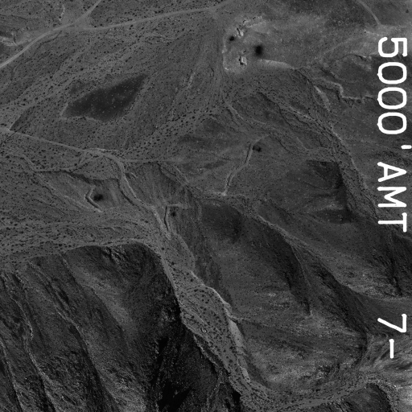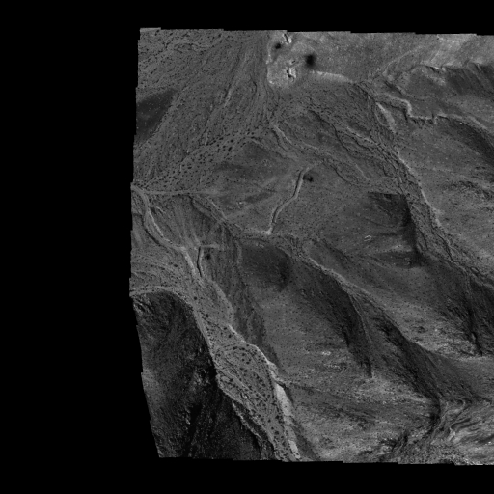
Original image Synthetic Image
Fig. 5 The third original image and synthetic image ( 2048 × 2048 )

Fig. 5 shows the third original image and the synthetic image used in the second experiment. Their magnified sub-images for a central area are shown in Fig. 6. A closer inspection clearly indicates that the third original image has some portion that are not seen in the synthetic image. However, most of the prominent points are consistently located in the identical position in both images.
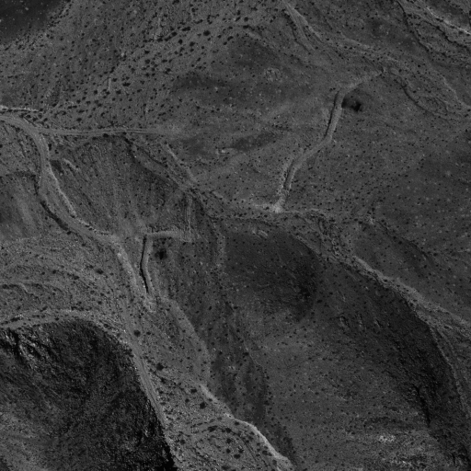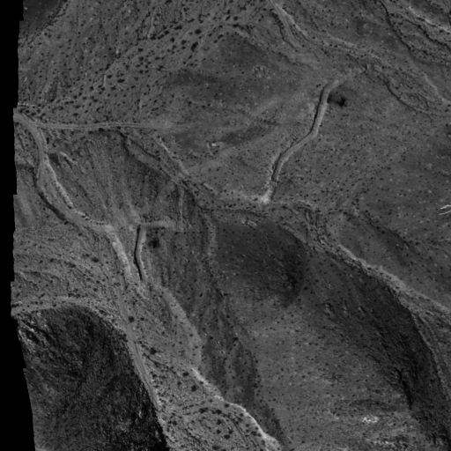
Original image Synthetic Image
(a)1024 x 1024
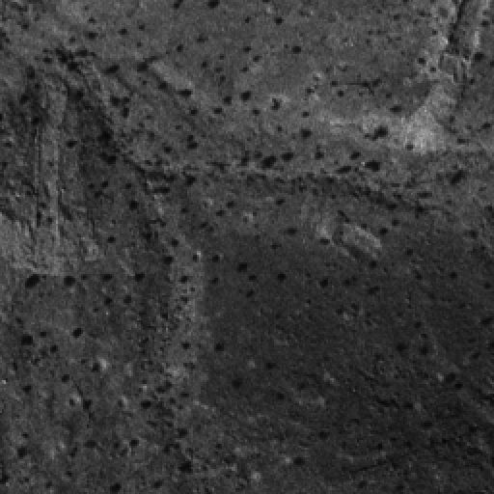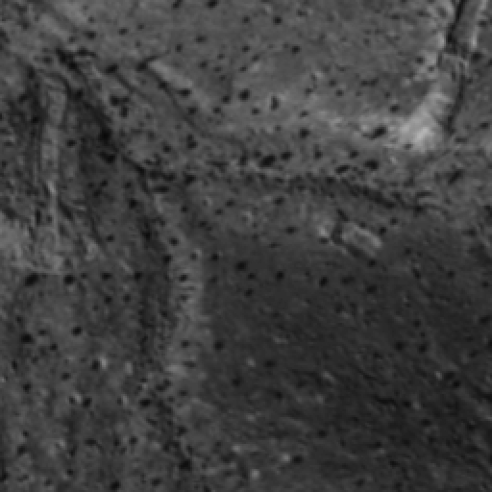
Original image Synthetic Image
(b)256 x 256
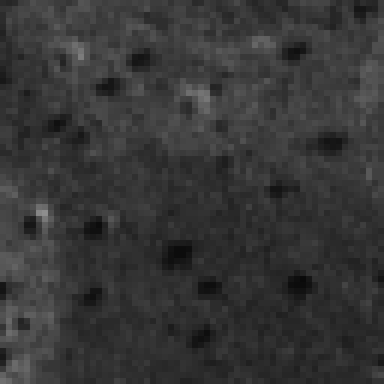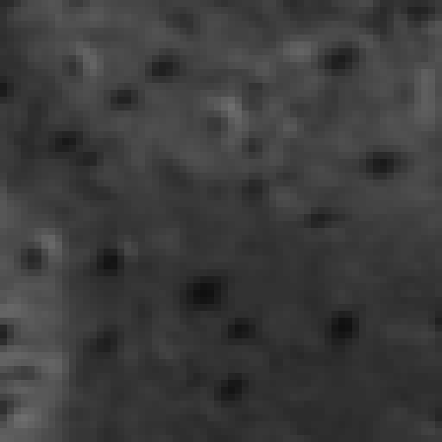
Original image Synthetic Image
(c)64 x64

Original image Synthetic Image
(d)16 x 16

Fig. 6 The third original image and synthetic image at several levels of magnification

Table 2 indicates errors in terms of disparity. In this experiment there is an increase in error magnitude by a factor of approximately 5 for an independent third image, compared to the first experiment with comparison to one of the original images generating the psudo ground truth. The average and rms disparity error increases to 28% of one pixel size. This figure may result from some occlusion, different lighting conditions and viewing angles, etc. photogrammetric error and the parts of the third original image which are not visible in the synthetic image, due to the *** ??? DONG-MIN - REST OF SENTENCE MISSING ***
Table 2. Error evaluated from the disparity d between the third image and the synthetic image (unit: pixel size)
window  size | Error
window  size | E1 = E[|d|] | E2 = E[d²] | E3 = E[d ]
9 x 9 | 0.206192 | 0.277571 | 0.041663
11 x 11 | 0.174443 | 0.234168 | 0.041791
13 x 13 | 0.151661 | 0.202227 | 0.042143
15 x 15 | 0.134858 | 0.177697 | 0.042782
17 x 17 | 0.122216 | 0.158476 | 0.043815
19 x 19 | 0.112742 | 0.143858 | 0.045125

VI. Qualitative Experiment

As another means of verifying the effectiveness of the proposed evaluation methodology, we assess in a qualitative manner our own quantitative use of this tool. We apply photo-realistic simulation to customize the size of the Terrest correlation window in a particular terrain domain for aerial reconstruction.

Based upon very clear theoretical principles we have strong expectations for the quantitative results of this experiment in parametric optimization in DEM accuracy with respect to the size of the correlation window[9]. There are two competing factors that must be balanced in any stereo reconstruction process. The error due to perspective distortion becomes larger as the size of the window grows. Pixels in the two correlation windows are increasingly misaligned, even when their center pixels are perfectly aligned, due to larger alignment errors of pixels that are distant from the window center [10]. To take a concrete example, consider a planar surface imaged at oblique angles inward, where opposite sides of the surface are foreshortened in the two correlation windows. Therefore, perspective distortion increases and match accuracy decreases with window size. This type of DEM error will appear evenly across the entire DEM. This implies that to minimize this effect of perspective distortion, the size of the window should be reduced, but not without limit. A competing factor is that as the size of the window becomes smaller, we are increasingly likely to generate matching errors (for a variety of reasons), each of which potentially can have very large spike error as an outlier.
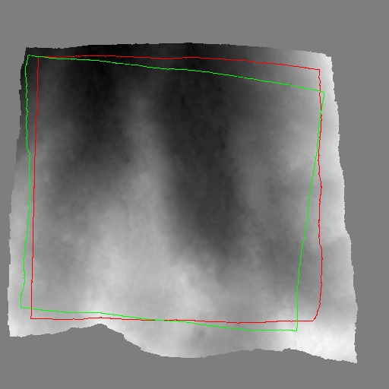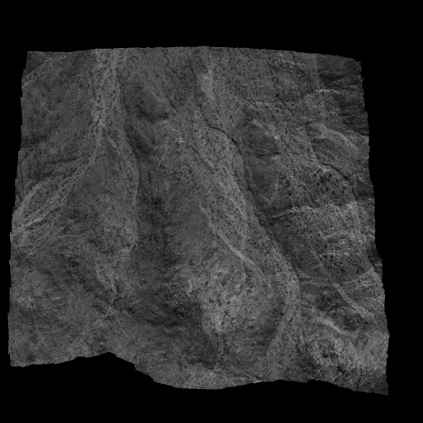
(a) DEM (b) ortho-image
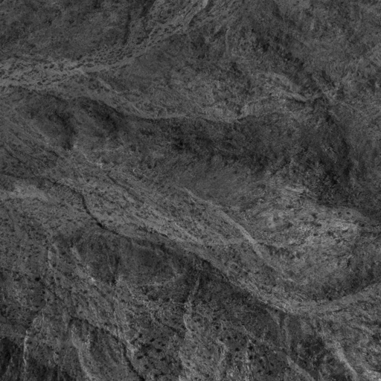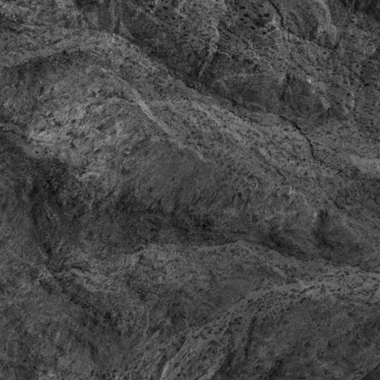
(c) synthetic image 1 (d) synthetic image 2
Fig. 7 Generation of synthetic images

In carrying out this evaluation of the correlation window on DEM accuracy with Terrest, the window size can be applied differently at each level of the multi-resolution matching scheme, which significantly complicates the analysis. To simplify this experiment, which is intended only for the qualitative verification of the proposed method, we use the same window size at each level. Also, we select an area of terrain with less occlusion for the pseudo ground truth to remove another complicating factor. Otherwise there might be terrain contexts that would actually deviate from expectation, but only due to unmodeled characteristics. Fig. 7 (a) and (b) depict the pseudo ground truth DEM and ortho-image, originally generated by aerial images of desert scene. The contour overlaid in Fig. 7 (a) is the projected area for the two synthetic images, as shown in Fig. 7 (c) and (d). Our synthetic images are generated at the viewing angles of Ω=Φ=0° and Κ=±90° I KNOW THIS IS DUE TO WORD DIFFERENCES THAT HAVE TO BE FIXED BUT I DON’T UNDERSTAND THESE ANGLES OF 0 AND 90 DEGEES. CAN’T WE JUST SAY “NAIDIR VIEWS”? However, the altitudes and baselines are set to be much lower and shorter than those of original images. WHY?

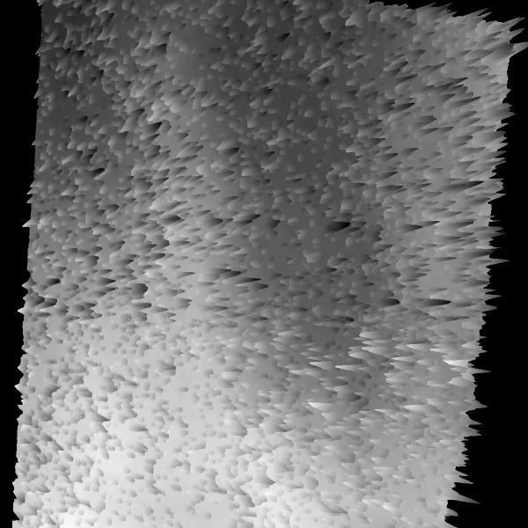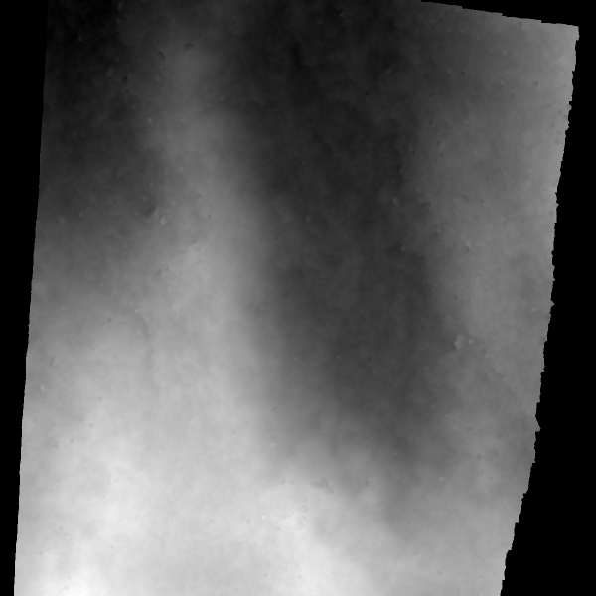
DEM with spike DEM without spike
(a) 3 x 3
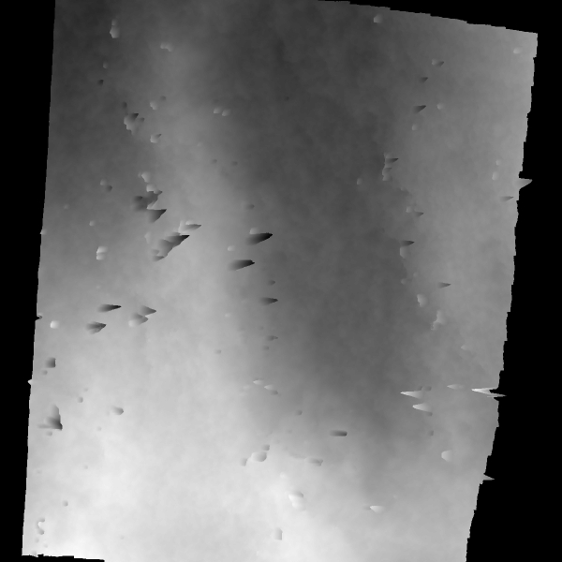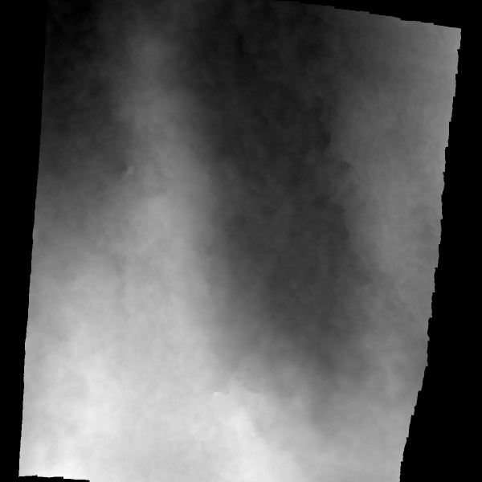
DEM with spikes DEM with spikes removed

(b) 7 x 7
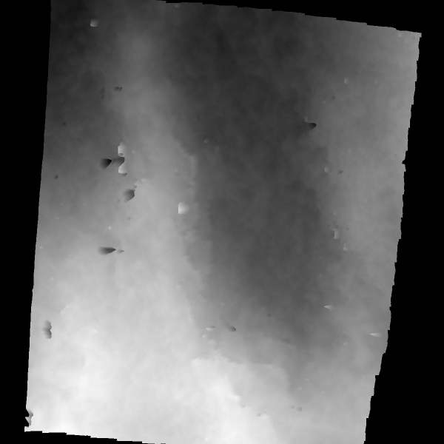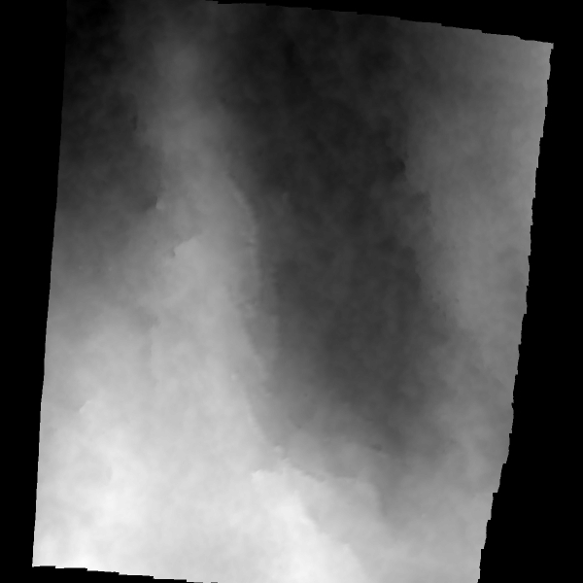
DEM with spikes DEM with spikes removed

(c) 11 x 11
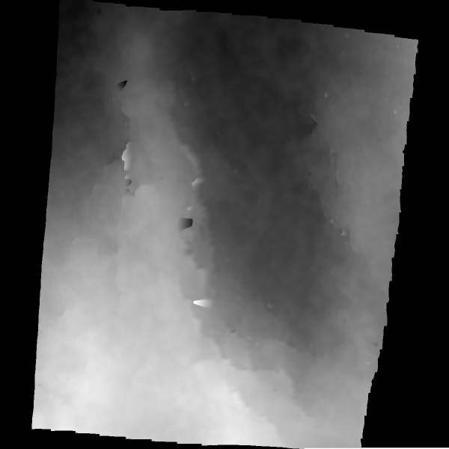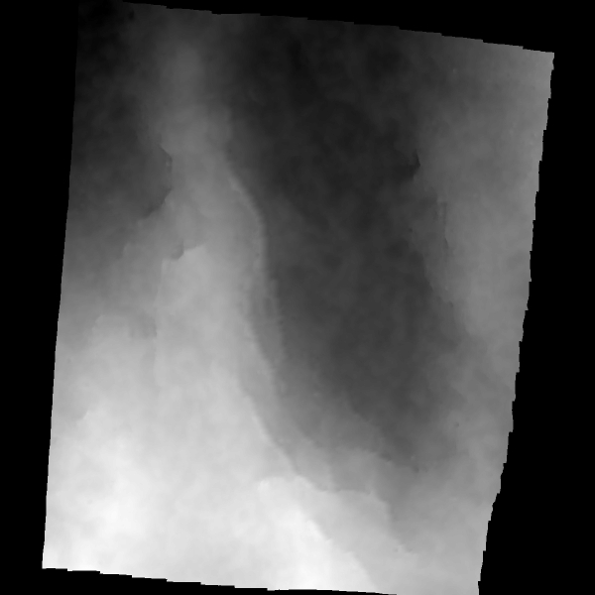
DEM with spikes DEM with spikes removed

(d) 15 x 15
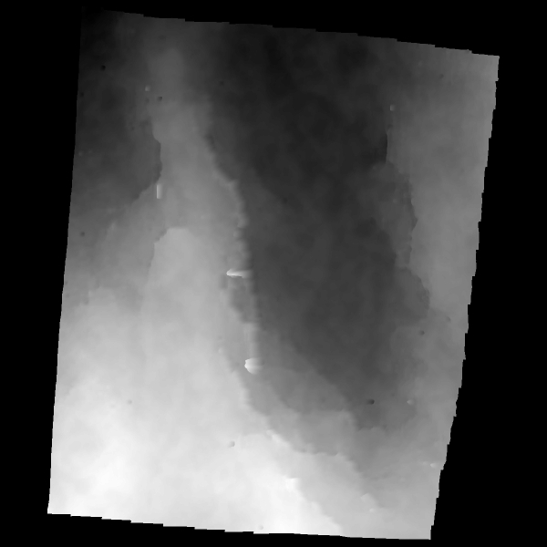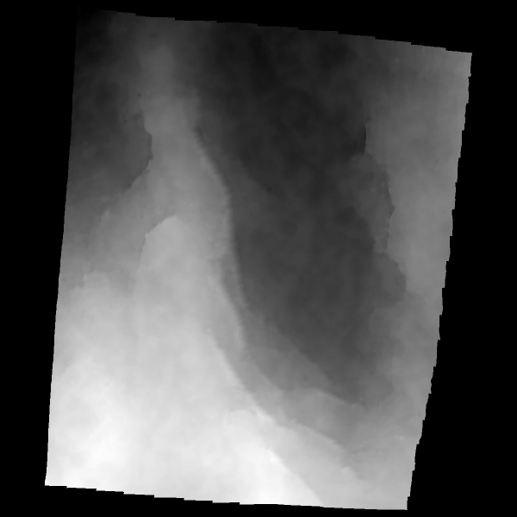
DEM with spikes DEM with spikes removed
(e) 17 x 17

Fig. 8 DEM generated by using varying size of correlation windows in 3D reconstruction with Terrest

Fig. 8 shows DEMs generated by 3D reconstruction as the correlation window is varied. Spike outliers are removed in a standard manner through median filtering of local neighborhoods. With a smaller window size, the spike types of outliers are observed far more frequently. These outliers can be detected by median filtering of the neighboring disparities and eliminated by substitution of the interpolated disparity. Fig. 7 shows DEMs generated by 3D reconstruction including spike elimination. With a 19x19 window the DEM is shown to be very smooth.

Table 3 summarizes the quantitative assessment of accuracy. Average error is associated with and dominated by contributions across all pixels, while the rms error is dominated by spike outlier errors. The average DEM error with spikes does not change significantly across small window sizes (beyond 3 x 3) because the perspective distortion increases, but the matching error decreases with modest increases in window size. As for the rms error, as expected we have the largest with 3x3 window and the smallest with 13x13. It appears that the best overall choice is a 13 x 13 window size without a spike removal process. When median filtering is used for spike removal, the DEM error - both average and rms - monotonically increases with increasing window size from 5x5 onward. In this case the error resulting from perspective distortion apparently dominates. One exception is with 3x3 window, where we get larger average DEM error than with 5x5 window. This occurs due to the many outlier spikes, as shown in Fig. 8 (a), and even the successful substitution of many interpolated values the performance of 3D reconstruction is still degraded. Obviously, 5x5 is the best choice for the window size when the median filtering is employed. This result of our analysis is absolutely consistent with our rough qualitative expectation, but the parameter is quantitatively optimized using our photo-realistic simulation tool. There would have been no way for us to have determined that a 5 x 5 window was best, and that average error would increase by approximately 20% and 60% for 7 x 7 and 9 x 9 windows, respectively. Thus, while other correlation window sizes might be reasonable for different types of terrain or imaging conditions, we are able to tune our algorithm for this image domain.
Table 3. DEM error as correlation window size is varied. Error in reconstruction measured against ground truth (unit: meter)
window  size | Error of DEM with spike |  | Error of DEM without spike
window  size | Average error E[|e|] | Rms error  √E[e²] | Average error E[|e|] | Rms error  √E[e²]
3 x 3 | 3.820631 | 6.399680 | 0.161612 | 0.386285
5 x 5 | 0.785736 | 2.874122 | 0.125846 | 0.253184
7 x 7 | 0.387964 | 1.806250 | 0.154254 | 0.271174
9 x 9 | 0.337733 | 1.311774 | 0.204980 | 0.365548
11 x 11 | 0.340495 | 1.060019 | 0.260392 | 0.452575
13 x 13 | 0.364696 | 0.863924 | 0.315674 | 0.535606
15 x 15 | 0.428795 | 0.975971 | 0.381458 | 0.646191
17 x 17 | 0.491957 | 0.964200 | 0.463993 | 0.797337
19 x 19 | 0.560241 | 1.043378 | 0.540334 | 0.931272

VII. Conclusions

We have proposed, demonstrated and evaluated a new methodology for assessing techniques of three-dimensional reconstruction based on photo-realistic simulation. This method addresses the prevalent lack of statistically significant amounts of ground truth data in 3D reconstruction of terrain. A digital elevation map and ortho-image is produced to serve as pseudo ground truth, and then this methodology can be efficiently applied to assess the effectiveness of the 3D reconstruction process and tune parameters of the associated algorithms.

We have provided quantitative and qualitative experimental results to demonstrate the effectiveness of the proposed method. We have shown that use of a good stereo terrain reconstruction system - the UMass Terrest system - quantitatively reproduces highly similar images with little difference in disparity from the original raw stereo pair, but now with millions of ground truth points in a dense DEM for use in further experimental evaluation. New views can be rendered from the psudo ground truth DEM and ortho image for testing of algorithms and tuning of parameters.

We have also presented a qualitative experiment in tuning one of the most critical parameters of stereo reconstruction, the size of the correlation window, so that Terrest was customized to the particular quality of the terrain being processed. We were able to understand quantitatively what the tradeoffs are with and without median filtering for spike removal, and the statistical impact on the resultant error.

Our methodology is under continuing development so that we can advance our understanding of a variety of complex issues in 3D reconstruction. We intend to examine methods for the automatic detection of occlusion errors in multi-image fusion. While errors can be detected automatically through use of additional images, there has not been an effective means of determining the types of errors in multi-image fusion[8].

REFERENCES

[1] T. Kanade and M. Okutomi, “A stereo matching algorithm with an adaptive window: theory and experiment,” IEEE Trans. Pattern Analysis and Machine Intelligence, vol. 16, no.9, pp. 920-932, 1994.

[2] N. Ayache and B, Faverjon, "Efficient registration of stereo images by matching graph description of edge segments," Int'l J. Computer Vision, pp. 107-131, 1987.

[3] P. Agouris and T. Schenk, "Automates aerotriangulation using multiple image multipoint matching," Photogrammetric Engineering and Remote Sensing, vol. LXII, no.6, pp. 703-710, 1996.

[4] P. Fua and Y. G. Leclerc, "Taking advantage of image based and geometry based constraints to recover 3D surfaces," Computer Vision and Image Understanding, vol.64, no.1, pp111-127, 1996.

[5] M. Hannah, "A system for digital stereo image matching," Photogrammetric Engineering and Remote Sensing, vol.55, no.12, pp.1765-1770, 1989.

[6] D. J. Panton, "A flexible approach to digital stereo mapping," Photogrammetric Engineering and Remote Sensing, vol.44, no.12, pp.1499-1512, 1978.

[7] Y. G. Leclerc, Q. Luong and P. Fua, “Self-consistency: a novel approach to characterizing the accuracy and reliability of point correspondence algorithms,” 1998 DARPA Image Understanding Workshop, 1998.

[8] H. Schultz, D. Woo, E. Riseman and F. Stolle, "Error detection and DEM fusion using self-consistency," IEEE Int. Conf. on Computer Vision, 1999.

[9] H. Mostafavi, "Image correlation with geometric distortion part II: effects on local accuracy," IEEE Trans. Aerospace and Electronic Systems, vol. AES-14, no. 13, pp. 494-500, 1978.

[10] H. Schultz, "Terrain reconstruction from widely separated images," Proceeding of SPIE, vol. 2486, pp. 113-122, 1995.

[11] E. Reinhard, A. G. Chalmers and F. W. Jansen, “Overview of parallel photo-realistic graphics,” State-of-the-Art reports in Eurographics ’98, pp. 1-25, 1998.

[12] T. Whitted, “An improved illumination model for shaded display,” Communications of the ACM, vol. 23, no. 6, pp. 343-349, 1980.

[13] C. M. Goral, K. E. Torrance, D. P. Greenberg and B. Battaile, “Modeling the interaction of light between diffuse surfaces,” SIGGRAPH ’84 Proceedings, vol. 18, pp. 213-222, 1984.

[14] S. N. Pattanaik, Computational Methods for Global Illumination and Visualization of Complex 3D Environments, Ph. D. Thesis, National Center for Software Technology, India, 1993.

[15] James Arvo, Graphic Gems II, Academic Press, 1991, pp. 257-263.

